ISO 26000 on social responsibility supports systemic/cybernetic behavior
(Some provocations for a workshop at LvB110, 10 Nov. 2011, Vienna, A)

Dr. Dr. Matjaz Mulej, Prof. Emeritus  (Systems and Innovation Theory)  University of Maribor, Slovenia,  IASCYS International Academy for Systems and Cybernetic Sciences (Vienna, Austria), President,  IRDO Institute for Development of Social Responsibility, Maribor, Slovenia | Dr. Zdenka Zenko, Ass. Prof.  (Systems Theory and Innovation Management)  University of Maribor, Slovenia  Anita Hrast, Gen. Manager  IRDO Institute for Development of Social Responsibility, Maribor, Slovenia

Key words: innovation, neo-liberalism, requisite holism, social responsibility

Due to the lack of systemic/cybernetic behavior the practical decision making has a one-sided and therefore misinforming basis. This has lasted for the entire industrial and information society periods. The dangerous climate change, over-population, lack of natural resources, and destruction of nature, including waste - all result from this absence, or lack, of requisite holism. The recent decade has seen official awareness of this dangerous absence of holism: United Nations and European Union launched documents supportive of social responsibility. In 2010 the ISO 26000 went a crucial step further: it calls (1) holistic approach and (2) interdependence the two common denominators of social responsibility.
Thus, these documents are asking for innovation of habits for humankind to overcome its dangerous economic theory of so far – the neo-liberalistic abuse of Adam Smith’s liberalism. Seven topics are addressed: (1) governance, management and organization, (2) human rights, (3) labor practices, (4) natural environment, (5) fair business practices, (6) customers, and (7) involvement and development of community.
Social responsibility is offering a replacement for neo-liberalism of so far in socio-economic relations, although only organizations, but no governments and individuals, are mentioned explicitly.
ISO 26000 is not meant for certification, but for self-assessment and self-innovation reaching beyond technology to crucial non-technological topics.
In the current trends, innovation may not be reduced to IIDP of products and services; it must rather cover the non-technological issues, too, or even first of all. Technology is an important tool, but only a tool of humans. See Table 1.
The 2008- crisis was not caused in 2008; it only surfaced then, as a consequence of the neo-liberal fictitious, rather than realistic, model of omnipotent market, causing also fictitious innovations by bank- and finance- people and the break of the fictitiously working real-estate market in USA (e.g.: ..Rop, 2011: in only 12 years the percentage of wealth owned by one single percent of Americans has grown from 37% to 70%, after 1995). This crisis is obviously much deeper: the market cannot be relied upon, because the ‘limited competition’, i.e. monopolistic market, does not work as the market’s invisible hand predefined by A. Smith (Smith, 2010). It does not prevent abuse of those with less bargaining power. It does not make the three notions of the French revolution – freedom, equality, and brotherhood – survive. Neither can goverments be realiable, if they are biased and onesided due to one-sided monopolisation and outvoting by the winning parties rather than requisitely or even totally holistic approach of parliaments. Thus, they can hardly attain the requisite wholeness of their insights and other outcomes. See Table 2.
'Innovation is every (!) novelty, once its users (!) find it beneficial (!) in practice (!)'.
Three networked criteria of inventions, suggestions, potential innovations, and innovations | (2) Consequences  of innovations |  | (3) On-job-duty to create inventions, suggestions, potential innovations, and innovations
(1) Content of inventions, suggestions, potential innovations, and innovations | 1. Radical | 2. Inc-remental | 1. Duty exists | 2. No duty
1. Business program items | 1.1. | 1.2. | 1.3. | 1.4.
2. Technology (products, work processes) | 2.1. | 2.2. | 2.3. | 2.4.
3. Organization (process-based rather than subordination-based) | 3.1. | 3.2. | 3.3. | 3.4.
4. Managerial style (co-operative rather than one-way commanding) | 4.1. | 4.2. | 4.3. | 4.4.
5. Methods of leading, working and co-working (supportive of co-operation) | 5.1. | 5.2. | 5.3. | 5.4.
6. Business style (co-operation with business partners) | 6.1 | 6.2 | 6.3 | 6.4
7. Governance & management process (supportive of co-operation) | 7.1 | 7.2 | 7.3 | 7.4
8. VCEN (supportive of co-operation and reflecting interdependence) | 8.1 | 8.2 | 8.3 | 8.4
9. Our habits (realizing contemporary VCEN in our practice) | 9.1 | 9.2 | 9.3 | 9.4
10. Habits of others (realizing contemporary VCEN in their practice) | 10.1 | 10.2 | 10.3 | 10.4
Table 1: 40 basic types of inventions, suggestions, potential innovation and innovations
-----------------------------------------------------------------------------------------------------------
Fictitious holism/realism (inside a single (subjectively selected) viewpoint) | Requisite holism/realism (a dialectical system of all (subjectively selected) essential viewpoints) | Total = real holism/realism (a system of all (objective rather than selected) viewpoints)
Table 2: The selected level of holism and realism of consideration of the selected topic between the fictitious, requisite, and total holism and realism
Five basic lines of measures to be undertaken are suggested:
- Individuals: to understand and practice, as consumers, to prefer real need over greed, and to prefer suppliers having a well-grounded image of social responsibility. Both has started happening in USA before the 2008 crisis (Gerzema, 2010; Zgonik, 2011).
- Organizations, both enterprises of all sizes and other: to understand and practice social responsibility as a human attribute and business strategy that prevents or diminishes, at least, cost resulting from dissatisfaction of people (e.g. in the form of visible and white strikes, cancelling and unreliability concerning contracts and resulting expensive search for new suppliers and customers, social riots all way to international terrorism, wars, etc.) and from unhealthy natural environment (e.g. in the need for eco-remediation and medication of humans and other nature; etc.).
- Country/government: to understand and practice that the public sector, as a whole, is the biggest customer and can therefore include in its procurement preconditions the demand and unavoidable precondition, which says that any organization from the public sector (from kindergarten to government offices and army, etc.) may be supplied only by suppliers that can prove to be the very top in the combination of (1) social responsibility, (2) innovation visible in the top business excellence and total quality of its supplies and its internal and external business practice, all way to its ‘systemic quality’ as a systemic synergy of suitable prices, pay-role, development funds, technical and commercial quality, innovativeness all way to uniqueness of its supplies, suitable range offered, sustainable care for its natural environment and other contents of social responsibility, (3) attainment of the same attributes with its own suppliers and their care for the same attributes of their suppliers.
- International community: understand and practice efforts to add to the international law, which is not obligatory and can therefore not be enforced except by agreement, especially concerning the multinational corporations, world peace, and the basic human rights, while only these three topics may be the role of the world-democracy including the world government made of very honest and socially responsible persons with no abuse of their influence.
- Systems/cybernetic science community
- Awareness building of the general need for:
  - Ethics of interdependence rather than dependence and independence (expect legal independence),
  - Requisitely holistic approach enabled by interdisciplinary creative cooperation,
- Provision of method supportive of interdisciplinary creative cooperation and ethics of interdependence;
- Exposing professionally the SR topics and especially the two concepts linking them: INTERDEPENDENCE and (REQUISITELY) HOLISTIC APPROACH.
Among other consequences, the economic and social theory should stop seeing the only dilemma in either market or central planning, and the engineering and natural sciences should stop seeing the only important factor in the technological innovation.
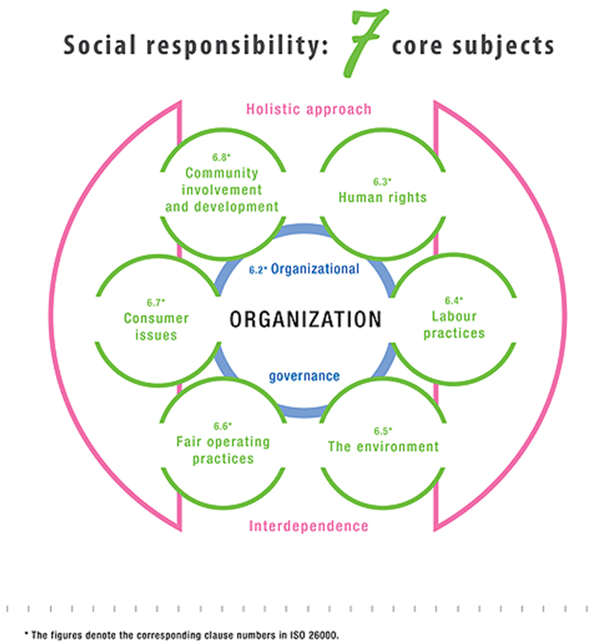
SR is offering a replacement for neo-liberalism of so far in socio-economic relations. Thus, informal systems behavior shows the way from the current global crisis.

Summary:

- SR = aimed at support to sustainable development
- SR = Honesty instead of abuse of power toward:
- Coworkers,
- Business and other partners,
- Broader society (incl. charity),
- Natural preconditions of human survival
- Well-being satisfaction motivation OK business performance business success
Organizations of all sizes and programs, private & public

SR – Beyond legal obligations

SR = VCEN & strategy of requisite holism (RH) based on interdependence, not (in)dependence
- reduces/eliminates troubles/costs caused by:
- lack of satisfaction ‚opportunity cost‘, e.g. by:
-- strikes & poor work,
-- lost markets,
-- lost suppliers,
-- lost partners,
-- lost good image/trust,
-- riots, terrorism,
-- eco-remediation,
-- medication, ..
i.e. by one-sidedness and abuse of power

SR – supports:
- competitive advantage;
- reputation;
- ability to attract and retain workers or members, customers, clients or users;
- maintenance of employees' morale, commitment and productivity;
- view of investors, owners, donors, sponsors and the financial community; and
- relationship with companies, governments, media, suppliers, peers, customers and the community in which it operates

SR = aimed to become a non-technological innovation via IID process

Why now:
- Until 1820 – GDP: 3% per 1000 years
- After 1820 – GDP: 5500% in 190 years
- After 1945: 2,5x more humans – 7x depletion of natural resources – 0x bigger planet Earth – further growth of production: for who & from which nature?
- 4 mil. tons of CO₂ in air, 1,7 mil. ton of nitrogen in soil, 1.500 ha of woods cut per hour; 2 deegres C more, methane survival? New initiative - SR
Holistic approach and interdependence (lines 896 – 900 in ISO 26000):
»An organization should look at the core subjects holistically, that is, it should consider all core subjects and issues, and their interdependence, rather than concentrating on a single issue. Organizations should be aware that efforts to address one issue may involve a trade-off with other issues. Particular improvements targeted at a specific issue should not affect other issues adversely or create adverse impacts on the life cycle of its products or services, on its stakeholders or on the value chain.«
Holistic approach and interdependence indirectly:
Stakeholders, accountability, transparency, ethical behavior, respect for rule of law and other rules, honesty, human rights, dialogue, wider impact, no abuse, no discrimination, healthy environment, no exploitation = interdependence considered (requisite) holism attainable by their interaction informal systems/cybernetics thinking/behavior
- Bertalanffy: 'against overspecialization',
- Wiener: 'interdisciplinary creative coooperation).

Table 3: From scarcity via complacency to the danger of a new scarcity or a new, 5th phase (with SR)
PHASE | ECONOMIC BASIS FOR DEVELOPMENT | RELATED Values, Culture, Ethics, Norms (VCEN)
1. Ownership of natural factors | Natural resources and cheap labor, providing for a rather poor life of majority for millennia | Scarcity and solidarity, collectivism, tradition rather than innovation
2. Investment in modern technology | Foreign investment into the area’s economic development; hardly/poor competitiveness in international markets | Growing differences, local competition, individualism, ambition to have more, be rich
3. Innovation based on local knowledge | Nation or region lives on its own progress and attains a better and better standard of living by international competitiveness | Growing differences and standard of living, global competition, ethic of interdependence, social responsibility, ambition to create
4. Affluence | People have finally become rich, which makes them happy in material well-being as a blind alley | Complacency, no more ambition, consumerism, greed > need; what is quality of life, then?
5. RH creation and social responsibility (SR) | Material wealth suffices; effort aimed at spiritual wealth, healthy natural and social environment as requisitely holistic well-being | Ethic of interdependence and SR, ambition to create, diminish social differences to those caused by creation, including innovation
- Either destruction or
- A prolonged innovation phase based on RH of IIDP rather than one-sided processes, or
- A new phase, a 5th one; it includes:
  - Creative happiness based on VCEN based on practice, and
  - Resulting ethics of interdependence and interdisciplinary creative co-operation
  - With SR replacing the content-empty phase of affluence;
  - For selfish reasons, people are less selfish, short-term thinking, and narrow-minded, and they apply more RH/SR, in order to survive; by
  - No more ‘Bubble Economy’ and extreme government/countries’ debts;
  - Sufficiency along with efficiency;
  - Jobs by shorter working hours and creative leisure/free time;
  - More holistic information added to GDP etc.

Table 4: Socio-economic development after the 2nd World War: from supplying to socially responsible enterprise (N.B.: X = synergy)
Decade | Market & Social Requirements | Enterprise’s Ways To Meet Requirements | Type of  Enterprise
1945- | Covering of post-war conditions of scarcity, rebuilding, etc. | Supply of anything; supply does not yet exceed demand | Supplying  Enterprise
1960- | Suitable price (as judged by customers) | Internal efficiency, i.e. cost management | Efficient  Enterprise
1970- | Add: X quality (as judged by customers) | Add: X technical & commercial quality management | Quality  Enterprise
1980- | Add: X range (as judged by customers) | Add: X flexibility management | Flexible  Enterprise
1990- | Add: X uniqueness (as judged by customers) | Add: X innovativeness management | Innovative  Enterprise
2000- | Add: X contribution to SD (as judged by customers) | Add: X sustainable development management | Sustainable  Enterprise
2010- | Add: X social responsibility | Add: X honesty reaching requisite holism and wholeness beyond legal demands | SR/RH enterprise

- Social responsibility: invention that must become innovation by the invention-innovation-diffusion process (IIDP)

- THE LACK OF SR - destroyed the slaves-owning and feudal societies room for democracy and free-market economy; NOW: surviving, called financial, neoliberal or feudal capitalism. SR much needed and discussed today.
- The ‘Bubble Economy’ cannot last. SR must replace it.
- CONTENT OF SR:
- charity, a mask for real one-sidedness rather than RH/SR/interdependence.
- European Union (EU, 2001) end of abuse of employees, other business partners, broader society, and natural preconditions of humankind’s survival, beyond law.
- EFQM – SR = human attribute, Business Excellence = measures toward SR
- Connection between systemic thinking and SR.
- SR world peace.
- ISO 26000 (ISO, 2010) - limited to organizations, same given socio-economic order
- IRDO: a next phase in socio-economic development – away from feudal capitalism.

